# Aon Member Letter

# Bestmed Medical Scheme 2025

**Dear Aon Client**

At Aon, we shape decisions for the better – to protect and enrich the lives of people around the world. We have pleasure in sharing the Aon on-line microsite platform for Bestmed Medical Scheme, which has been developed to provide you with essential information to make better decisions regarding your medical scheme and gap cover requirements.

It is important that at this time of the year you evaluate your current healthcare arrangements to ensure the most appropriate cover for 2025. Whether you wish to remain on your current option or change to a more suitable option for 2025, it remains Aon’s responsibility to guide you through the review process. This will ensure that you make an informed decision regarding your healthcare cover for 2025.

The information provided in this letter is a summary of changes within the Bestmed options. For more detailed information and clarity on your benefits and contributions please refer to the Aon Microsite. Please find link on page 5**.**

**Benefits and Contributions Update for 2025**

**What is the contribution increase for 2025?**

Bestmed Medical Scheme has announced a weighted average contribution increase of 12.75% effective 1 January 2025.

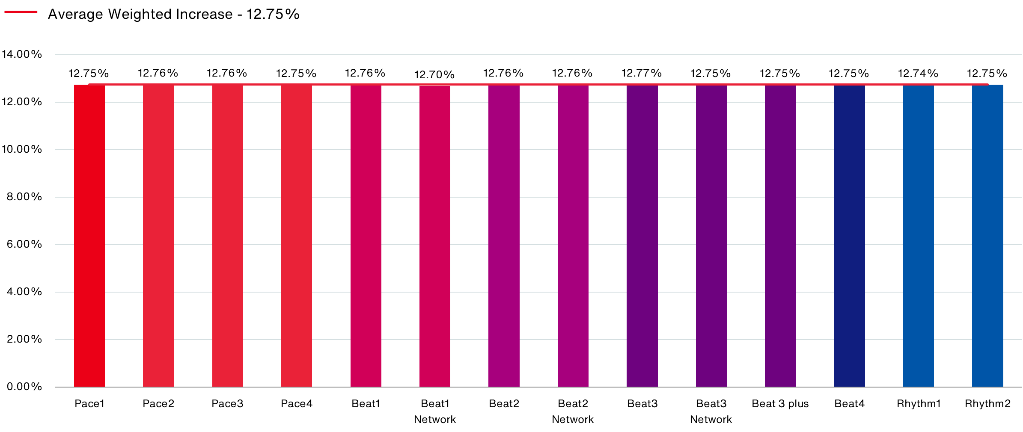

Click [here](https://aon.io/3YbCzH4) to access 2025 contribution table which includes Annual Medical Savings.

Benefit Limit Increases

* The weighted average benefit limit and sub-limit increase is 4.6%.

Key Benefit changes

* Specialised diagnostic imaging (MRI scans, CT scans, nuclear/isotope studies and PET scans). Limited to a combined in- and out-of- hospital rand value per family and subject to a co-payment per scan, not applicable to PMBs. PET scans are noted separately.
* An Orthopaedic and medical appliances benefit is added to Beat and Pace range and is limited to R15 000 per family per annum.
* Procedure specific co-payments will apply to Beat and Rhythm options.
* Take-home medicine – this benefit will continue to cover a maximum of 7 days’ treatment; however, it will need to be claimed as part of the hospital account. If not claimed as part of the hospital account, a rand value will be imposed if claimed on the same day of discharge at a retail pharmacy or no payment if not claimed on day of discharge.
* Benefits added to Rhythm1
  + - Mammogram benefit for females aged 40 and above every 24 months,
    - Pap smear (pathology only) benefit for females aged 18 and above every 24 months,
    - Over-the-counter medicine (OTC) benefit limited to R240 per family per annum and R120 per event.

Benefit Reductions

* Female contraceptive benefit was adjusted for all options.
* Child dependant age - Dependants under the age of 24 years are regarded as child dependants. Students up to the age of 26 years will no longer be considered at child dependant rates.
* The Hearing aid benefit was adjusted on Pace2, 3 and 4.
* On Rhythm2 the Over-the-counter medicine (OTC) benefit is reduced to R350 per family per annum and R120 per event.

For more information on the changes to the Bestmed options in terms of benefits and contributions – please refer to the Microsite.

**Gap Cover**

Aon strongly supports the purchasing of Gap Cover to compliment your medical scheme, to reduce your out-of-pocket exposure for in-hospital events. We recommend you speak to your Aon Consultant to assist you in selecting the correct Gap Cover option.

**Microsite**

At Aon, we shape decisions for the better – to protect and enrich the lives of people around the world. We have pleasure in sharing Aon’s online platform which has been developed to provide you with the clarity and confidence to make better decisions regarding your medical scheme and gap cover requirements.

To access the microsite please click this link: <https://eb.aon.co.za/transnet/>

**Year-End training sessions**

Aon will be conducting virtual and in-person training sessions on the relevant information pertaining to the 2025 medical scheme options. These sessions will elaborate on medical scheme benefit changes, enhancements, and contribution increases.

**When will in-person training sessions be held?**

The dates for these sessions will be communicated by your HR department.

**How do I book an individual session with the Aon Consultant to discuss my personal circumstances?**

If you cannot decide whether you need to change your existing option, despite having read all the information, please contact the Aon Resolution Centre (ARC) or your dedicated Aon Healthcare Consultant.

The Aon consultant will either be available on the day of the training session, or your HR department will advise when the consultant will be available for a one-on-one session.

Please ensure that you e-mail your dedicated consultant as mentioned below, to schedule an individual one-on-one session.

|  |  |  |  |
| --- | --- | --- | --- |
| Region | Consultant | E-mail address | Contact |
| Free State | Leonie Fourie | leonie.fourie@aon.co.za | 0514117638 |
| Northern Cape |
| Western Cape | Melville Marais | melville.marais@aon.co.za | 0214424009 |
| Eastern Cape | Noxolo Stemele | noxolo.stemele@aon.co.za | 0415088624 |
| KwaZulu-Natal | Nhlanhla Mpisi | nhlanhla.mpisi@aon.co.za | 0315341099 |
| Gauteng | Joslinah Heymann | joslinah.heymann@aon.co.za | 0119447322 |
| Pretoria | Nontu Msomi | nontu.msomi@aon.co.za | 0119447598 |
| East Rand |
| Northwest | Ashley Adams  Jacob Radebe | ashley.adams1@aon.co.za | 0119447245 |
| Mpumalanga | jacob.radebe@aon.co.za |  |
| Limpopo |

**Where do I get more information and who can I contact if I have any questions?**

Bestmed Medical Scheme call centre can be contacted on 086 000 2378 or WhatsApp 068 376 7212 for the clarification of benefit changes and contribution increases and the **Aon Resolution Centre (0860 100 404) or email on arc@aon.co.za** will also be available to provide advice on option selections for 2025.

**Bestmed option change? (Consultants to customise this section)**

Please notify Bestmed in writing by no later than 30 November 2025 by completing the attached option change form. To complete the form please click [here](https://na2.docusign.net/Member/PowerFormSigning.aspx?PowerFormId=2699cbd2-c511-44f9-8a98-6f525737abcd&env=na2&acct=2b18d1d9-cb63-4a68-a191-c6d735547f20&v=2).

Option changes to be forwarded to [membership@bestmed.co.za](mailto:membership@bestmed.co.za)

***It is important to note that no late changes will be accepted.***

**Connect with us**

We focus on communication and engagement, across insurance retirement and health, to advise and deliver solutions that create great client impact.

We partner with our client and seek solutions for their most important people and HR challenges.

We have established presence on social media to engage with our audiences on all matter related to risk and people.

For more information from Aon Employee Benefits on healthcare, retirement benefits and a wide range of topics feel free to go to [www.aon.co.za](http://www.aon.co.za)

**Aon Employee Benefits – Healthcare**

Aon South Africa (Pty) Ltd is an Authorised Financial Services Provider License # 20555

<http://www.aon.co.za/disclaimer>

On all services provided, Aon’s Terms & Conditions of Business, as amendments from time to time, are applicable and can be found at <http://aon.co.za/terms-of-trade> or will be sent to you upon request.

<https://www.facebook.com/aon.healthcare>

Click “Like” on our page (Aon Healthcare)



[https://x.com/Aon­_SouthAfrica](https://x.com/Aon_SouthAfrica)

Click “follow” on our profile



**About Aon**

Aon plc (NYSE: AON) exists to shape decisions for the better — to protect and enrich the lives of people around the world. Through actionable analytic insight, globally integrated Risk Capital and Human Capital expertise, and locally relevant solutions, our colleagues provide clients in over 120 countries with the clarity and confidence to make better risk and people decisions that help protect and grow their businesses.

© Aon plc 2024. All rights reserved.

On all services provided, Aon’s Terms & Conditions of Business, as amendment from time to time, are applicable and can be found at <http://aon.co.za/terms-of-trade> or will be sent to you upon request.

**Disclaimer:** The benefits and contributions are subject to approval by the council for medical schemes**.** Although care is taken to represent the rates and benefits correctly, errors and omissions could occur. In case of any conflict, the rules of the affected medical scheme prevail. Any decisions regarding your medical scheme portfolio should be made in conjunction with your Aon Employee Benefits consultant or manager. While Aon has taken reasonable steps to ensure that the information contained in this report is relevant, accurate and current, no warranties of any kind, whether express or implied, including but not limited to the accuracy, completeness, relevance, or fitness for a particular purpose are given and Aon expressly disclaims any liability for any loss or damage that may arise from the use of this report. This report is confidential and intended solely for the use of the individual or entity to whom it is addressed. If you received this report in error, you should not disseminate, distribute, or copy this report and you should notify Aon if you are not the intended recipient and destroy the report. The report is copyright of Aon SA (Pty) Ltd. You may not, except with our express written permission, distribute or commercially exploit the report. Aon hereby authorizes you to copy the report for non-commercial use within your organization

Please click [**here**](https://www.aon.co.za/media/1hsjlifr/2024_healthcare-privacy-notice-20240627-v4.pdf)**,** to view the Aon South Africa (Pty) Ltd Healthcare privacy notice.